**WEEK 4**

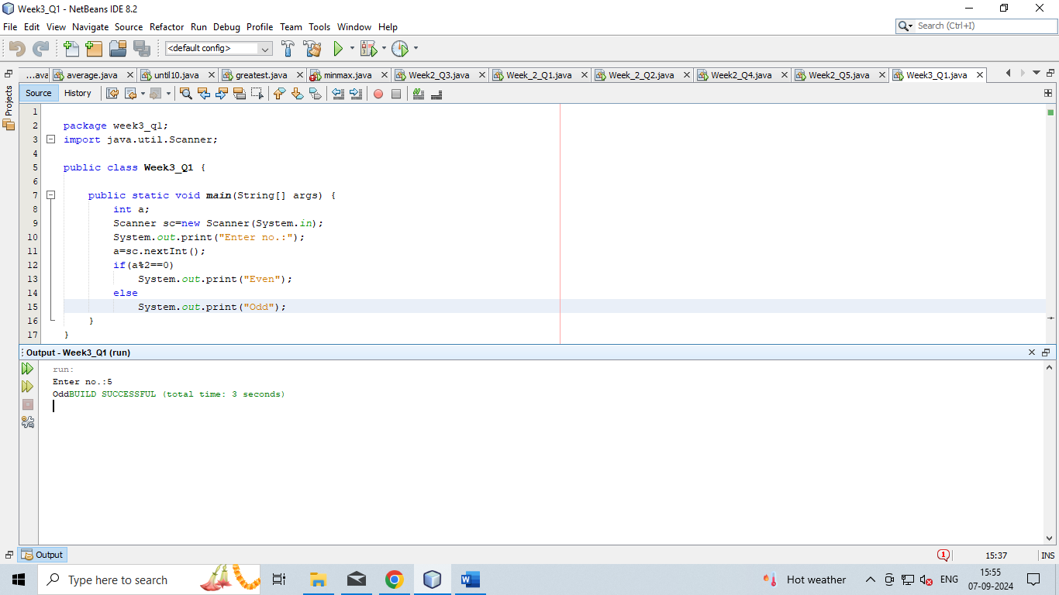**Q-1:Write a java program to check whether the given number is odd or even.**

**Q-2:Write a java program to find the largest number among the three numbers.**

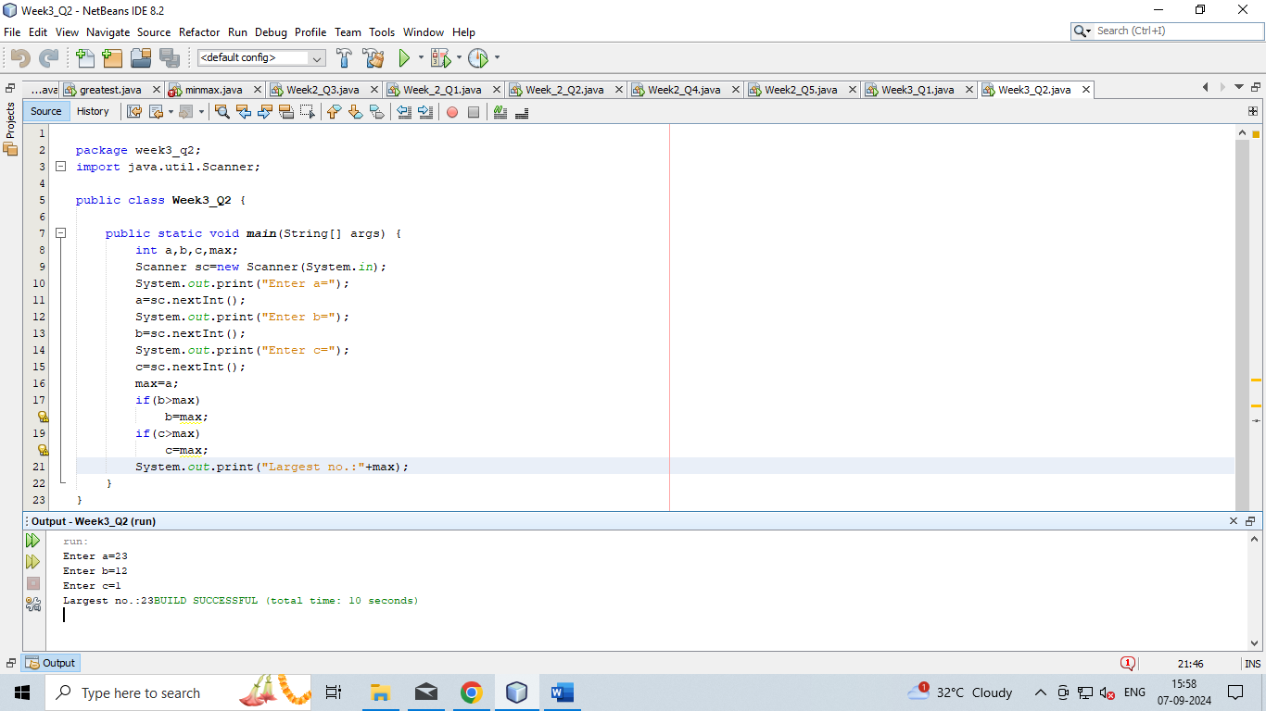

**Q-3:Write a Java program that takes a number as input and prints its multiplication table upto 10.**

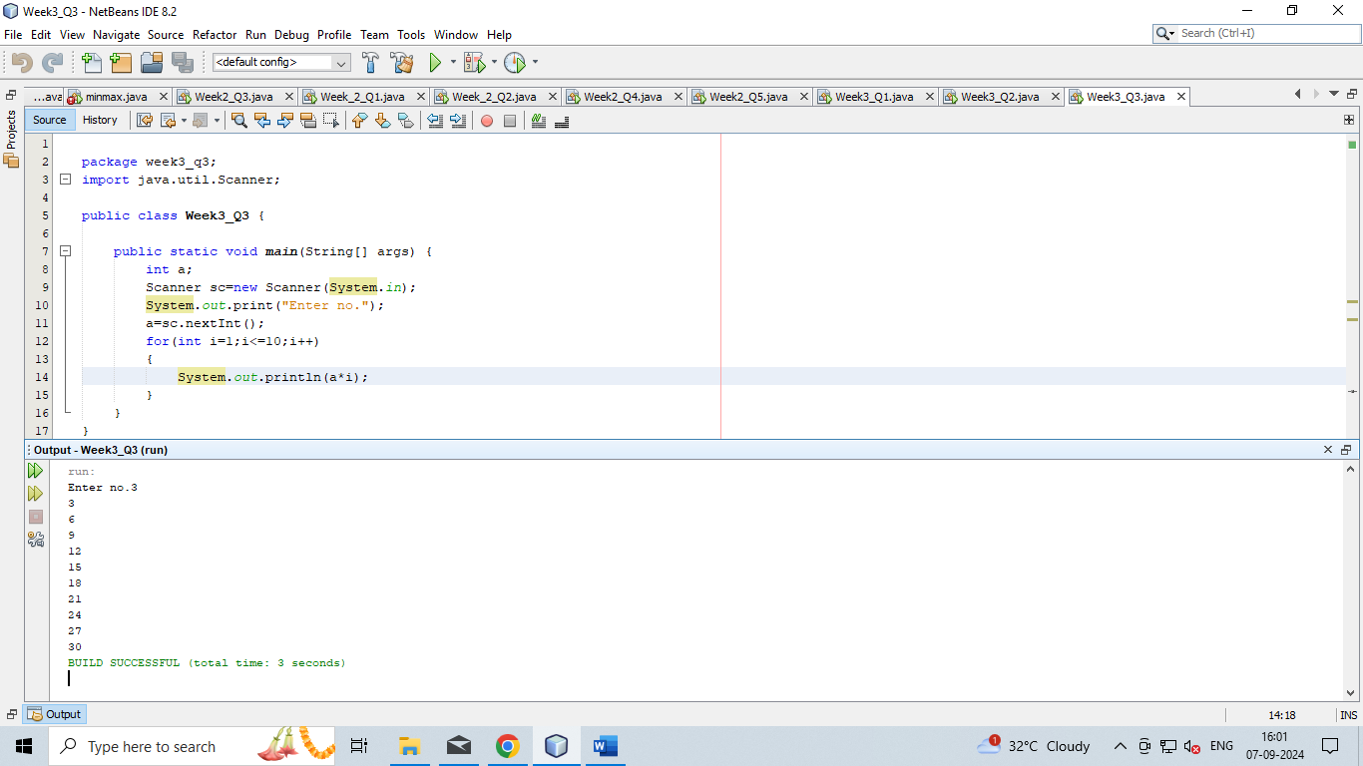

**Q-4:Write a Java program to calculate the sum of following series: 1 + 2 + 3 + 4 + .......... + N**

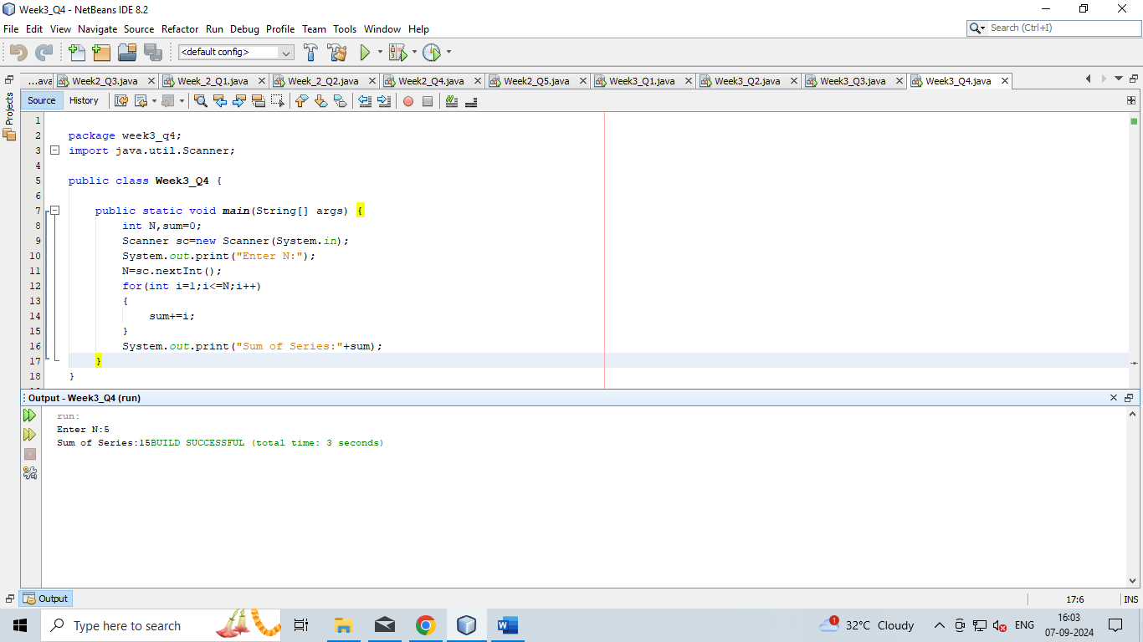

**Q-5:Write a Java program to take a number, divide it by 2 and print the result until the number becomes less than 10.**

